**EXPERIMENT-19**

**IOT BASED SMART HOME APPLICATIONS**

**Aim**: To implement IoT based smart home applications in Cisco Packet Tracer.

**Software/Apparatus required**: Packet Tracer/End devices, Hubs, connectors.

**Procedure:**

**Steps:**

1. Create a network topology in Cisco Packet Tracer that includes IoT devices such as sensors, actuators, and gateways.

2. Configure the IoT devices with appropriate IP addresses, subnet masks, and gateway addresses.

3. Set up a communication protocol between the IoT devices using MQTT, CoAP, or any other protocol of your choice.

4. Write a code to collect data from the sensors and send it to the gateway.

5. Use the gateway to process the data and send commands to the actuators.

6. Finally, use a web interface or mobile application to monitor and control the IoT devices.

By following these steps an IoT-based smart application in Cisco Packet Tracer , can be created. This can be used for various applications such as home automation, smart cities, and industrial automation.

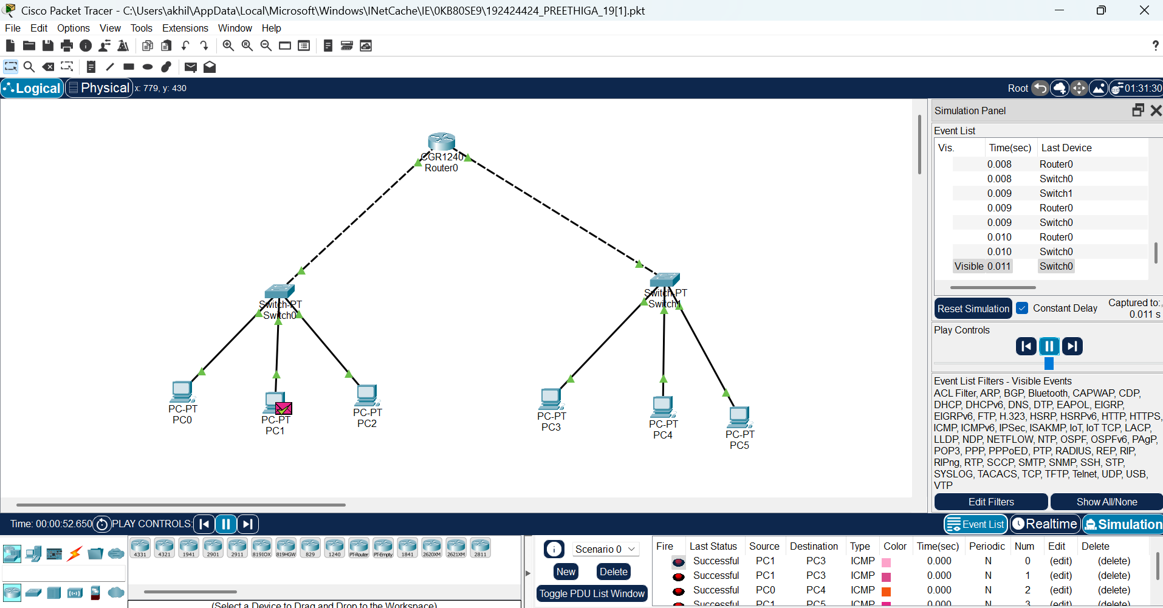Result: Thus IoT based smart home applications in Cisco Packet Tracer is implemented successfully